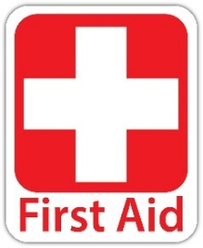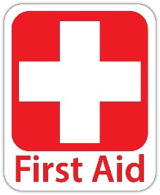

QUICK REFERENCE

COMMON ALIMENTS

FIRST AID

FOREIGN MATTER IN EYE:

**Symptoms**: Irritation, redness, pain, unable to open eye, visual problems.

**Treatment**: Flush eyes with water or use eye wash kit, check if debris in eye can be removed, remove carefully with clean tissue. If unable to remove or if pain and inability to open eye persists seek medical attention. If yellow drainage is present, seek medical attention.

NOSE BLEEDS:

**Treatment**: Sit upright and slightly lean forward. Pinch notrils for 5-10 minutes or until bleeding stops. DO NOT blow your nose. If bleeding continues, apply ice to bridge of nose or back of neck and/or apply pressure to upper lip.

EARACHE:

**Treatment**: Hold a hot water bottle or compress on ear, control pain with over-the-counter medications, consult physician if pain persists and accompanied by a fever.

TOOTHACHE:

**Treatment**: Rinse mouth with warm salt water to remove debris, take over-the-counter medication for pain as needed, apply ice to face, a topical anesthetic may be applied for temporary relief, see the dentist as soon as possible.

WOUND CARE:

**Treatment**: Clean wound with hydrogen peroxide. If necessary pack wound with gauze/cloth material. Apply pressure to wound to control bleeding. Apply tourniquet above wound if bleeding continues.

**HOW TO CALL FOR HELP**

***STAY CALM!*** Getting hysterical often panics the victim and inhibits communication with emergency medical services, causing more harm and delay.

When calling for help, give: precise location, address and telephone number from where you are calling (if address is unknown look for landmarks and businesses), the nature of the emergency/injury, and number of people involved, your name, ages and gender of victims.

**QUICK TIPS**

* Substitute a frozen bag of vegetables for an ice pack.
* Put ice in a reusable zip-lock bag and cover in paper towel/cloth.
* Do not use cotton on an open wound.
* Always have hydrogen peroxide on hand for minor cuts/scrapes.
* If wound is really dirty, dab/pour hydrogen peroxide, avoid squirting directly into wound.
* Keep ipecac syrup available to induce vomiting, **only if recommended by poison control!**

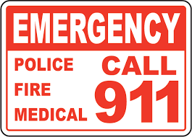

SUPPLIES:

* Band-Aids (assorted sizes)
* Cotton swaps to apply creams/ointments
* Disposable gloves
* Elastic bandages
* Rolled gauze
* Flashlight
* Duct tape
* Blanket
* Plastic bag
* Scissors
* Bucket
* Snacks (power bars/candy bars, etc)
* Water

MEDICATIONS:

* Acetaminophen to relieve pain and reduce fevers
* Aloe Vera gel to treat sunburns
* Antacids for indigestion
* Antibiotic ointment for superficial wounds to prevent infection
* Antidiarrheal
* Aspirin (NEVER given to children under 18 or pregnant women)
* Calamine lotion for rashes/bug bites
* Hydrocortisone cream for rashes/bug bites
* Ibuprofen for pain relief and fever/inflammation reduction
* Prescribed medications

FIRST AID

COMMON AILMENTS

FIRST AID KIT CHECKLIST

FAINTING:

**Symptoms:** (That fainting is about to occur) sensation of dizziness, weakness, cold sweats, rapid pulse, and ringing of the ears.

**To Prevent Onset:** Have person sit down with their head between knees or lay down and elevate feet.

**If Victim Faints:** Raise feet 12-15 inches, apply wet/cool wash cloth to forehead. If consciousness does not return within 8 minutes, call rescue.

HYPERVENTIL

HYPERVENTILATION:

**Symptoms:** Deep, rapid, irregular breathing, the feeling of loss of control of breathing.

**Treatment**: Calm the person. Ask them to concentrate on taking slow, deep breaths. If this is not effective, call rescue.

CONCUSSION:

**Symptoms:** (Caused by a blow to the head) severe headache, dizziness, sudden urge to sleep, vomiting, increased pupil size, restlessness, agitation, irritability.

**Treatment**: Monitor level of sleepiness, do not let victim fall asleep. Call rescue or bring victim to E.R.